YES | Not yet

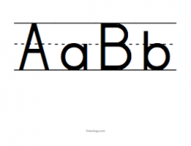

I can make my letters on the line

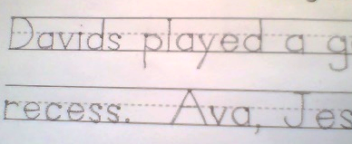
I can put spaces between words

I can put a period where it goes.
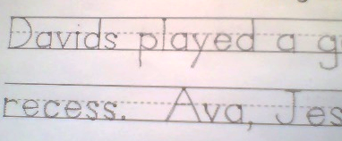
I can use a capital letter where I need to.

I can find a heading in a text.

I know what the heading is used for.

I can find the table of contents.

I know how to use a table of contents.

I can find captions and labels in a text.

I how what captions and labels are used for in a text.

Name_____________________________

