Narrative
Writing 3: Recount two or more appropriately sequenced events (W.1.3) ELP 3

I can identify two or more sequenced events to include in the narrative.

Writing 3: Include details regarding what happened

I can use details that match the event.
Writing 3: Use temporal words to signal events order

I can use words in my writing to tell my reader the order that things happen.

Writing 3: Provide a sense of closure
I can write an ending to my story to let my reader know I’m done.

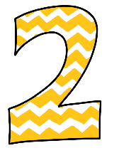 | Students will recognize or recall specific vocabulary, such as: closure, detail, event, narrative, sequence, time order  I know these words: closure, detail, event, narrative, sequence, time, order  With support, I can identify two or more sequenced events to include in my narrative.  With support, I can choose details that match the event.  With support, I can use words in my writing to tell my reader the order that  things happen.  With support, I can write an ending to tell my reader when I am done.

