I am learning | to | compare
two 2-digit | numbers | using >, <, =.

Students will be able to recall vocabulary such as greater than, less than, equal to, less, greater, compare, greatest, least, tens, and ones.

What level do you think you are at on the scale?
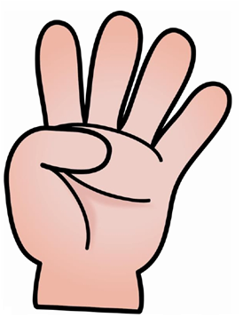
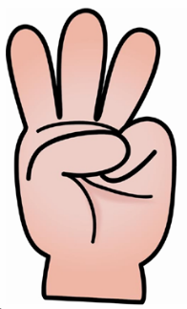
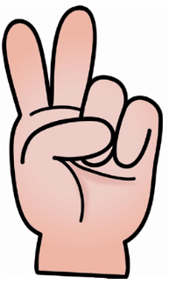

1 | 2 | 3 | 4

Explain:

