Finish this week’s learning goal using the correct words from the word bank below.
I am learning | to | __________
__________ | Numbers.

Students will be able to compare 2-digit numbers using <,<,=.

What level do you think you are at on the scale?
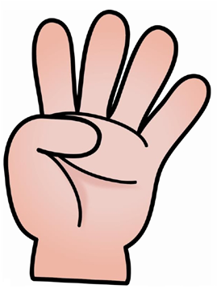

1 | 2 | 3 | 4

