Phonological Awareness
RF.1.2.a Distinguish long from short vowel sounds in spoken single-syllable words.

I can tell the difference between all long and short vowel sounds.

RF.1.2.b. Orally produce single-syllable words by blending sounds, including consonant blends.

I can blend sounds in words together, even words with blends (pl, st, bl, tr)

RF.1.2c Segment spoken single-syllable words into their complete sequence of individual sounds)

I can say the beginning, middle and end sound when my teacher or friend says a
word.

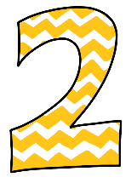 | I know at least 2 of the vowel sounds and the sounds they can make.  I can blend 3-letter words together. C-a-t  With support, I can say the beginning, middle or end sound when my teacher or friend says a word.

