Tens and Ones
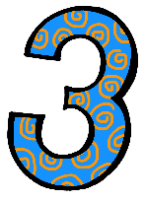 | Understand that the two digits of a two-digit number represent amounts of tens and ones. . (NBT.B.1)  I can make groups of ten with some ones.  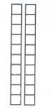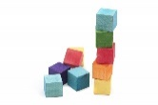  I can show that numbers 11 to 19 are made of a ten and some ones.  I can use cubes to show that numbers like 20, 30, 40, 50, 60, 70, 80, and 90 are made  of some tens and 0 ones. .
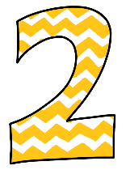 | I can make numbers like 20 or 30 with cubes.  I can group cubes into tens but may have some difficulty counting them.  s.

