Math Performance Scale
Unit 1 Goals: | Counting Relationships up to 120  Students demonstrate they have the ability to: Count numbers up to 120, starting at any number less than 120. (1.NBT.1)  When given a written numeral (up to 120), student represents with objects. (1.NBT.1)
4 | I can count and recognize the patterns above 120. | 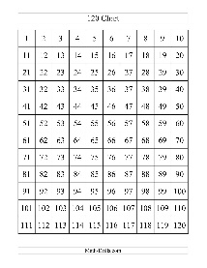
3 | I can count numbers up to 120, starting at any number less than 120. | 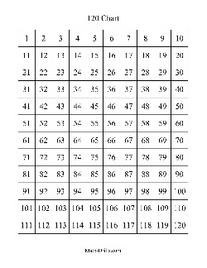  84, 85, 86, 87. . . . .
 | I can show the number of objects when given a written number (up to 120). | Show me 82
2. | I understand the following words  Count, number, numeral
 | I can count and write numbers up to 55. | 1, 2, 3, 4, 5, 6, 7, 8, 9. . .  55
 | I can show the number of objects when given a written number (up to 55). | 16
Unit 1 Goals: | Intro to Number Sense and Number Relationships  * Combines parts of arrangements by knowing  * Know how many to add on or take away by counting on or removing extras  * Combines quantities into one ten and leftovers
4
3

2. | I understand the following words

