Story Elements
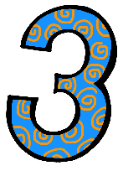 | Describe characters in a story.(.RL.1.3)  - I can describe characters in a story by drawing a picture of the characters  Identify setting of a story.(.RL.1.3)  - I can identify the setting of a story.  Describe characters in a story.(.RL.1.3)  I can identify the major events of a story.  Identify the beginning, middle, and end of a story..(.RL.1.3)  I can identify the beginning, middle, and end of a story.
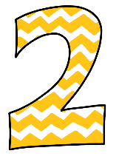 | - I know these words: character, event, setting, beginning, middle, end  - I can identify the characters of a story.  - I can sometimes identify the major events of a story.  - I can sometimes identify the beginning, middle, and end of a story.

