Theme and Central Ideas
Identify the main topic and the key details of a text (RI.1.2)
- I can retell key details from a text

- I can use the key details to identify the main topic of a text.

Determine the central message of a lesson of stories (RL.1.2)
- I can explain the lesson of a story.

Retell the story using key details (Rl.1.2)
- I can retell key details from a story.

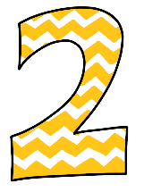 | - I know these words: main topic, detail, lesson, main idea, retell, story, text, topic  - I can tell 1 key detail from a text.  - I can recognize the lesson in a story.

