Point of View
R.I.1.6 Distinguish between information provided by pictures or other illustrations and information provided by the words in a text (RI. 1.6)
I can tell if the information is from the picture.

I can tell if the information is from the text.

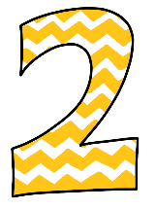 | With support, I tell if the information is from the picture or the text.

