I know and can use Text Features
 | I can draw a picture and include text features.
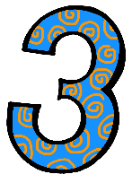 | R.I. 1.5 Know and use various text features to locate key facts in a text  I can identify text features.  - I can identify a caption  - I can identify a label  - I can identify a heading  - I can identify a table of contents  I can use text features to help me understand the text.  - I can use the table of contents to find information  - I can use the heading to know what I’m going to read  - I can use a caption to learn facts about the picture  - I can use a label to identify something in the picture
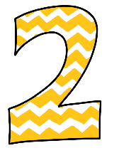 | With support I can identify a caption, label, heading and table of contents  With support, I can use the text features to help me understand a picture  