Making Connections Within a Text
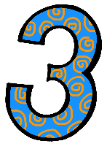 | Describe how two individuals, events, ideas, or pieces of information in a text connect(RI.1.3)  - I can describe how two ideas are connected.
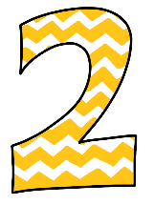 | - I know these words: connection, event, idea, individual, information, text, effect, cause  - I can identify individuals, events, or ideas from a text.

